Arada, Diego Marcus M. AM22

Formative 1 Web Design

1. Give at least five of your favorite websites and identify the components/parts of the given URL.

* [YouTube](https://www.youtube.com/)
  + Scheme – https://
  + Subdomain – www.
  + Second-level domain – youtube
  + Top-level domain – .com
* [Facebook - log in or sign up](https://www.facebook.com/)
  + Scheme – https://
  + Subdomain – www.
  + Second-level domain – facebook
  + Top-level domain – .com
* [Instagram](https://www.instagram.com/)
  + Scheme – https://
  + Subdomain – www.
  + Second-level domain – instagram
  + Top-level domain – .com
* [Netflix Philippines - Watch TV Shows Online, Watch Movies Online](https://www.netflix.com/ph/)
  + Scheme – https://
  + Subdomain – www.
  + Second-level domain – netflix
  + Top-level domain – .com
  + Subdirectory - /ph/
* [Watch Anime Online, Watch English Anime Online Subbed, Dubbed (9anime.id)](https://9anime.id/)
  + Scheme – https://
  + Second-level domain – 9anime
  + Top-level domain – .id

2. Search and take a screenshot of the websites that have the TLD suffix:

* .eu
* .edu
* .jp

<https://worldoftanks.eu>

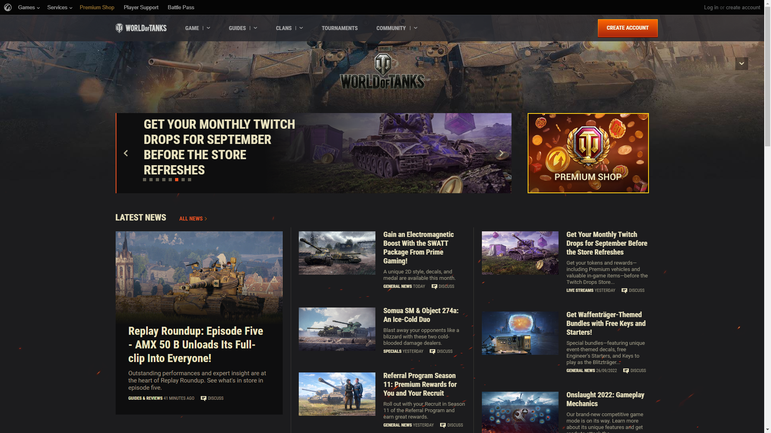

<https://www.feualabang.edu.ph>

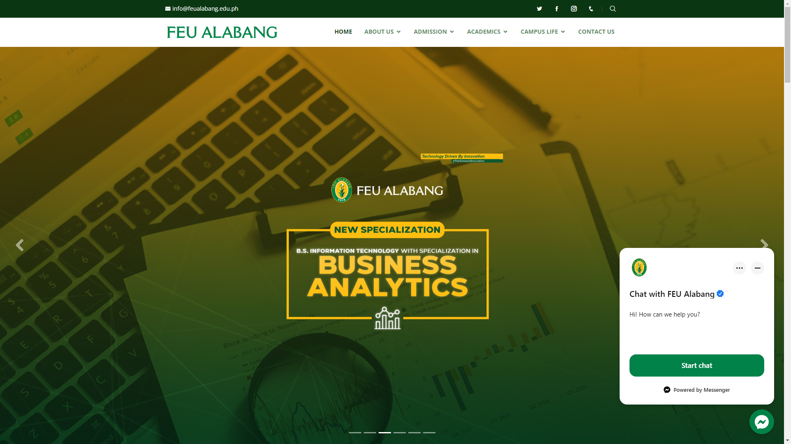

<https://www.nicovideo.jp>

